**Question 1**

My reflection on the Data Analytics process and my experience of using Alteryx.

Reflecting on the Data Analytics process and my experience with Alteryx, it becomes evident that data analysis is integral to an analyst's role. In this context, Alteryx emerges as a noteworthy software tool pivotal in enabling data analytics. While engaging in the data analytics process, the consistent utilisation of robust data transformation tools like “Select,” “Formula,” “Filter,” and “Date time” within Alteryx proved instrumental in addressing complex data-related challenges. These tools facilitated crucial tasks such as column renaming, data type alteration, numerical calculations, and data filtering, greatly enhancing the software's value proposition and streamlining the analytical process. Furthermore, Alteryx excels in data integration, offering support for 35 diverse file types to facilitate seamless data importation into the software for analysis. This extensive file type compatibility underscores Alteryx's comprehensive and well-rounded nature in the realm of data analytics. The critical feature I find most valuable in Alteryx is its code-free nature. Its array of tools, such as "Join," "Union," and "Summarize", enable the execution of highly complex tasks. For instance, the "Join" tool facilitates merging separate worksheets based on a shared attribute. Moreover, it offers multiple variations accessible to individuals without coding experience.  
  
Despite its benefits, Alteryx presents particular challenges in the context of data analytics. For example, in my workplace, we primarily use Power BI to create various options for data visualisations and reports, which Alteryx does not offer. This required adapting to a different tool for those specific tasks. Additionally, Alteryx's error explanations can be complex for beginners, and it lacks a recommended solution tool to address mistakes during data analytics, posing a challenge for new users.

In summary, while Alteryx's advantages are significant, it does have some limitations. It remains an excellent tool for big data, and its data analytics capabilities are robust. Over time, I navigated the challenges, quickly adapting to the software's requirements, interpreting data, and employing data manipulation tools to address questions. Through practice, I improved in manipulating data and better understood the software's functionality.

**Question 2 - Objective of the analysis**

Question 1:

The goal was to identify the hotel's seasonal trends, enabling them to make well-informed decisions about their business. This involved using various data manipulation tools in Alteryx to determine the average length of stay and total revenue earned per month.

Question 2

The analysis aims to identify the tickets sold by a distributor in a single genre. Another objective was to determine the average number of tickets sold and filter the movies that sold more than the average number of tickets.

Question 3

The analysis aims to establish a workflow using various data manipulation tools in Alteryx to minimise the shipping distance by item.

**Question 3 – Data cleaning and manipulation**

**Question 1**

As I created a new column of check-in dates, I encountered a problem. Alteryx advised that they were not able to convert the dates. As per the image below, the dates were set up as 29 February 2022, which is not a leap year.   
  
Using a formula to keep the data consistent, I changed the dates from February 29th to February 28th. I also realised that this would affect the reservation status column, so as a proactive step, I updated the dates in the reservation status formula from February 29th to February 28th.

See the image below for the formula I used and the final result.

For this question, I also used the DateTime tool to convert the check-in date, which was in “V_Wstring” format, to a “date.” I named the new column “Check In Date DT.” I also used the DateTime tool to convert the reservation_status_date, which was in “V_string” format, to a “date.” I named the new column “reservation_status_date DT.”

BEFORE

AFTER

**Question 2**

Upon examining the data, null rows were identified in the Genre and Distribution columns. These null rows were removed to conduct accurate data analysis. After applying the filter, segregate the null rows in the false column as possible, as shown in the image below.

False Data

True Data

Further, in question 2, the Filter was again used to segregate records of movies that sold more than the average number of tickets.

**True**

False

A summarize tool was also used to calculate aver number of tickets sold.

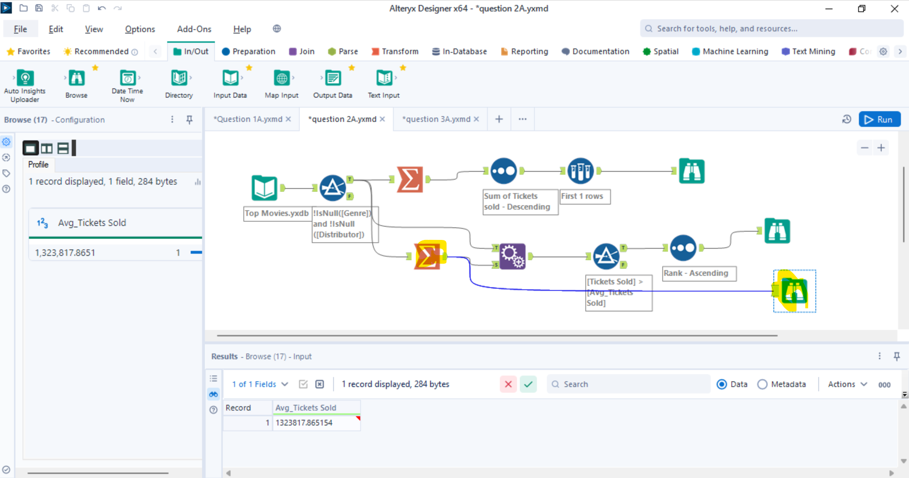

**Question 3**

I used the join tool to combine the store priority and store requirement Excel files into one data source, using the store as the common denominator.

The summarizer tool also calculated the total distance travelled per item.

Finally, the sort tool was used to arrange Items in ascending order.

**Question 4 – Results**

**Question 1**

**Question 3**

